
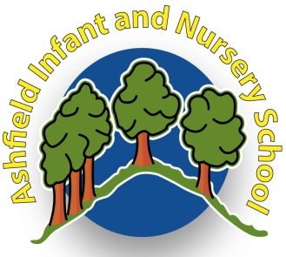
Updated April 2023

Safeguarding Children - the action we take to promote the welfare of children and protect them from harm - is everyone’s responsibility.
IF A CHILD MAKES A DISCLOSURE OF ABUSE OR NEGLECT OR SHARES ANYTHING OF CONCERN:
Please do the following:
• Listen calmly
• Write it down afterwards so you can remember the details.
• Do not question the child.
• Do not promise to keep it a secret.
• Report your concerns immediately to the child’s class teacher and/or our Designated Teacher Mrs Barclay or Mrs Ives in her absence.

Doing nothing is not an option; it is our duty to safeguard the children in our care at all times.

For further information regarding this leaflet, please contact:
Mrs Field or, in her absence, Mrs Ives.
Please follow the advice in this leaflet and keep yourself and our children safe.
Thank you for your co-operation.

At Ashfield Infant and Nursery School, we are very proud and fortunate to have a very dedicated and supportive school community. At our school the staff, governors, parents and carers all recognise that the education of our children is a partnership between us.

We expect our school community to respect our school ethos, keep our school tidy, set a good example of their own behaviour both on school premises and when accompanying classes on school visits.

This Code of Conduct summary is designed to give clear guidance on the standards of behaviour all volunteers working with children in our school are expected to observe. Adults are role models, are in a unique position of influence, and must adhere to behaviour that sets a good example to all the pupils within the school. As a member of a school community, every adult has an individual responsibility to maintain their reputation and the reputation of the school.
Our full Code of Conduct for Staff, Governors and All Adults is available on request and on our website.
Code of Conduct for Volunteers and Students
Newlands Lane
Workington
CA14 3JG

admin@ashfieldinf.cumbria.sch.uk
http://www.ashfieldinf.cumbria.sch.uk/

Ashfield Infant and Nursery School
Volunteers should NEVER:
- Accept children as friends on social media websites.
• Give or receive gifts from children.
• Put online any text, image, sound or video that could upset or offend any member of the whole school community
• Make, or encourage others to make sexual remarks to, or about, a pupil;
• use inappropriate language to, or in the presence of, pupils.
• Enter into, or encourage, inappropriate discussions, which may offend or harm others.
• behave in a manner, which would lead any reasonable person to question their suitability to work with children or to act as an appropriate role model.

Volunteers should ALWAYS:
- Only touch children when it is absolutely necessary and appropriate for their well-being and safety.
- Wear sensible clothing which will not cause offence.
- Treat all pupil issues and those of other adults in school with the highest standards of confidentiality.

When you visit or volunteer to work in our school, you agree to follow this code of conduct in order to keep children and yourself safe. Should a concern or allegation arise, the Head or Chair of Governors will seek advice from the Local Authority Designated Officer (LADO). Safeguarding is everyone’s responsibility!

Ashfield Infant and Nursery School
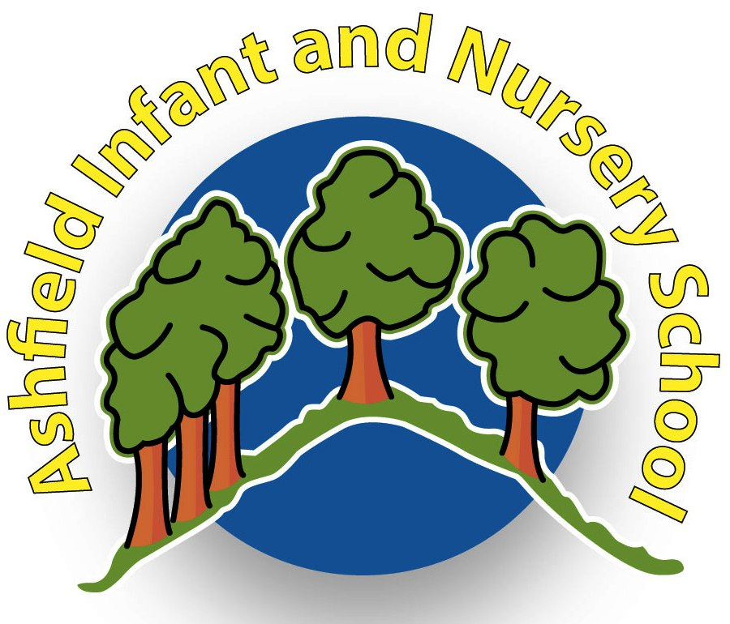
Nothing is more important than children’s welfare. Everyone who works with children has a responsibility for keeping them safe.
Adults working at or visiting the school site play an important part in the life of the school and the wider community.
We can all play a part in keeping children safe whilst working at or visiting our school. This leaflet applies to all adults in whatever capacity who come into school.
Please follow our Code of Conduct

All those who come in conduct with children through their everyday work, whether paid or voluntary, are responsible for their own actions and behaviour. You should avoid any conduct which could lead any reasonable person to question your motives and intentions.
At Ashfield Infant and Nursery School, we have a duty to safeguard and promote the welfare of our children. All adults will therefore:
- Be a positive role model: set a good example by being respectful, fair and considerate to all.
- Treat children equally: never build a “special relationship” or favour a particular child over others.
- Always act in the child’s best interests.
- Treat information you receive in school about pupils in a discreet and confidential manner.
- Ensure that when working with an individual child, that you are visible to others at all times and not behind closed doors.
Volunteers should NEVER:
- Use a mobile phone or communication devices for ANY purpose while children are present.
- Exchange emails, text messages or phone numbers with children
- Shout at children other than as a warning in an emergency/safety situation;
- Express any prejudicial views; attempt to influence or impose their personal values, attitudes or beliefs on pupils.
Volunteers should ALWAYS:
- Report any situation where a pupil becomes distressed or angry;
- Have another adult present
- Abide by the school’s Acceptable Use Agreement and Online Safety Policy
If you are worried about a member of staff’s actions, speak to Mrs Barclay or in her absence Mrs Ives. If you are worried about the actions of the Headteacher, speak to the Acting Chair of Governors, Mrs Deborah Wilkinson.

