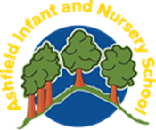
Name of school | Ashfield Infant and Nursery School
Date of policy | December 2023
Member of staff responsible | Michelle Jones
Link Governor

Review date | May 2026
RE Policy 2025- 2026

Introduction
Religious Education is unique in the school curriculum in that it is neither a core subject nor a foundation subject but the 1988 Education Act states that ‘Religious Education has equal standing in relation to core subjects of the National Curriculum in that it is compulsory for all registered pupils’.
Religious Education is taught in our school because it makes:
“a major contribution to the education of children and young people. At its best, it is intellectually challenging and personally enriching. It helps young people develop beliefs and values, and promotes the virtues of respect and empathy, which are important in our diverse society. It fosters civilised debate and reasoned argument, and helps pupils to understand the place of religion and belief in the modern world”. (RE: realising the potential, Ofsted 2013).
This fits with our school ethos of children becoming good citizens in a nurturing environment. Being a good citizen is at the heart of everything we do and includes our school values such as respect, kindness and friendship.
Ashfield Infant and Nursery school is a community school. We deliver RE in line with the Locally Agreed Syllabus for Cumberland. We use the Jigsaw RE programme as our scheme of work.
This RE policy is informed by current national guidance:
- RE in English Schools: Non-statutory guidance 2010 (https://www.gov.uk/government/uploads/system/uploads/attachment_data/file/190260/DCSF-00114-2010.pdf)
- RE : realising the potential Ofsted 2013 (www.ofsted.gov.uk/resources/religious-education-realising-potential)
- A Curriculum Framework for RE in England, REC 2013 (http://resubjectreview.recouncil.org.uk/re-review-report)
- Cumberland SACRE

The aims of our RE, using the Jigsaw RE Scheme of Work
Jigsaw RE meets the requirements of our locally agreed syllabus and is aligned to the non- statutory guidance described above.
By following Jigsaw RE at Ashfield Infant and Nursery School school we intend that Religious Education will:-
- adopt an enquiry- based approach as recommended by Ofsted, beginning with the children’s own life experience before moving into learning about and from religion.
- provoke challenging questions about the meaning and purpose of life, beliefs, the self, and issues of right and wrong, commitment and belonging. It develops pupils’ knowledge and understanding of Christianity, other principal religions, and religious traditions that examine these questions, fostering personal reflection and spiritual development.
- encourage pupils to explore their own beliefs (religious or non-religious), in the light of what they learn, as they examine issues of religious belief and faith and how these impact on personal, institutional and social ethics; and to express their responses.
- enable pupils to build their sense of identity and belonging, which helps them flourish within their communities and as citizens in a diverse society.
- teach pupils to develop respect for others, including people with different faiths and beliefs, and helps to challenge prejudice.
- prompt pupils to consider their responsibilities to themselves and to others, and to explore how they might contribute to their communities and to wider society. It encourages empathy, generosity and compassion.
- develop a sense of awe, wonder and mystery.
- nurture children’s own spiritual development.

Jigsaw RE Content
Jigsaw RE covers all areas of RE for the primary phase, Christianity plus one other religion is taught in each year group in KS1. The grid below shows specific enquiries for each year group.

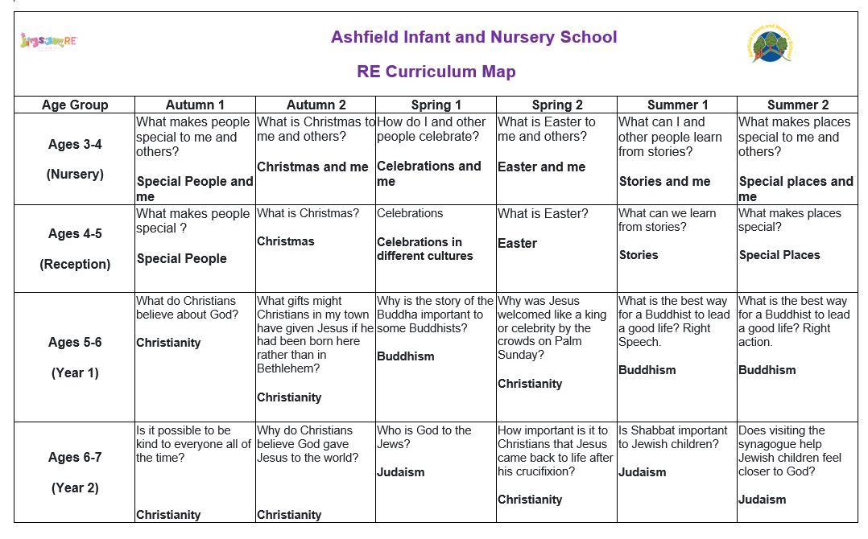

How is RE organised in this school?
Jigsaw RE brings together learning about and from religion, questioning and spiritual development in a comprehensive scheme of learning. Teaching strategies are varied and are mindful of teaching and learning theories and the need for adaptive teaching. Each enquiry starts from the children’s own life experiences using these as a bridge into the investigation of the religion being studied.
Learning is assessed and children have opportunity to express their own thoughts and beliefs and empathise with believers of that religion or belief position.
In KS1 RE is taught weekly. RE is taught during a specific week during each half term in Reception. This allows children to be fully immersed in their learning allowing them to focus and think deeply about the RE theme.

SEND Provision
Jigsaw RE is written as a universal core curriculum provision for all children. Inclusivity is part of its philosophy. Teachers will add to the planning to meet the needs of the children in their classes. To support this, many enquiries suggest creative learning activities that allow children to choose the media with which they work and give them scope to work to their full potential. To further help teachers adapt the teaching, for children in KS1, each enquiry has exemplars for those children working towards the learning objective, at the expected level for this age group and those working beyond the expected level of achievement.
Assessment
Teachers are eager to ensure children are making progress with their learning throughout their RE. Therefore, each enquiry has built-in assessment. This task is the formal opportunity for teacher assessment of the children’s knowledge of that religion, depth of critical thinking, and ability to answer the enquiry question. This stand-alone evidence is used in conjunction with other evidence such as records of discussions, recorded work and annotations from other lessons within the enquiry to assist the teacher in assessing whether a child is working at the expected level or towards or beyond it. Children are assessed over three aspects of learning:
- a personal resonance with or reflection on the material/religion being studied to answer the enquiry question.
- knowledge and understanding of the material/religion being studied to answer the enquiry question.
- evaluation/critical thinking in relation to the enquiry question
These are tracked throughout the planning stage so that teachers can utilise the appropriate evidence accordingly. In line with non-statutory guidance issued by the RE Council in 2013 (Cumberland SACRE) descriptors of these aspects utilise age–related expectations of working towards, working at the expected attainment and working beyond.
Recording and tracking progress
To support the teacher in tracking each child’s progress throughout the year, there is an overview sheet for each enquiry on which to record the progress of the whole class. This supports teacher overview and facilitates subject leader monitoring and moderation. Termly data is recorded on Scholar Pack, the schools data system.
Reporting to Parents/Carers
The assessment process described above helps teachers report to parents/carers. Jigsaw RE enquiries give teachers meaningful evidence to cite in reports.
Monitoring and evaluation
The RE leader monitors delivery of the programme through observation and discussion with teaching staff, as well as discussions with children and scrutiny of their written work to ensure consistent and coherent curriculum provision.
Evaluation of the programme’s effectiveness is conducted on the basis of:
- Pupil and teacher evaluation of the content and learning processes
- Staff meetings to review and share experience
- Monitoring of assessment to ensure progression throughout the school.

Learning walks are conducted as well as practical work being evidenced on Tapestry.

External contributors
RE gives particular opportunities to promote an ethos of respect for others, challenge stereotypes and build understanding of other cultures and beliefs. This contributes to promoting a positive and inclusive school ethos that champions democratic values and human rights. The British Values agenda is intrinsic to Jigsaw RE.
External contributors from the community, e.g. local clergy, local members/speakers from other religions etc make a valuable contribution to the RE programme as do visits to places of worship. Their input is carefully planned and monitored so as to fit into and complement the programme.
Teachers are always present during these sessions and remain responsible for the effective delivery of the RE programme.

The Learning Environment
Establishing a safe, open and positive learning environment based on trusting relationships between all members of the class, adults and children alike, is vital. To enable this, it is important that respect for each others’ views and beliefs and those of the believers of that religion is encouraged at all times and that any artefacts are handled with respect and care. For this reason we provide the Jigsaw RE Charter.
Teaching Sensitive and Controversial Issues
Sensitive and controversial issues are certain to arise in learning from real-life experience and discussing personal beliefs.
Topics are presented using a variety of views and beliefs so that pupils are able to form their own, informed opinions but also respect that others have the right to different opinions. Teachers should never feel obliged to discuss their own beliefs unless they feel comfortable doing so and can ensure that this will not influence or restrict the children’s own expression.
Involving parents and carers
The school believes that it is important to have the support of parents, carers and the wider community for the RE programme. Parents and carers are/will be given the opportunity to find out about and discuss RE through:
- Response to RE comments on reports
- Curriculum newsletters
- Displays
- Tapestry

Withdrawal from RE lessons

Parents/carers have the right to withdraw their children from all or part of the Religious Education. Those parents/carers wishing to exercise this right are invited in to see the head teacher and/or RE Leader who will explore any concerns and discuss any impact that withdrawal may have on the child. The school will ensure that parents who want to withdraw their children from RE are aware of the RE syllabus and that it is relevant to all pupils, and respects their own personal beliefs. Parents will be made aware of the learning objectives and what is covered in the RE curriculum and should be given the opportunity to discuss this, if they wish. The school may also wish to review such a request each year, in discussion with the parents.

The use of the right to withdraw should be at the instigation of parents and it should be made clear whether it is from the whole of the subject or specific parts of it. No reasons need be given. Where parents have requested that their child is withdrawn, their right must be respected, and where RE is integrated in the curriculum, the school will need to discuss the arrangements with the parents or carers to explore how the child’s withdrawal can be best accommodated. Once a child has been withdrawn they cannot take part in the RE programme until the request for withdrawal has been removed.

As a school it is our duty to inform our local Standing Advisory Council on RE regarding the numbers of children being withdrawn.

Links to other policies and curriculum areas
We recognise the clear link between RE and the following policies and staff are aware of the need to refer to these policies when appropriate.
- Teaching and Learning Policy
- Equal Opportunities Policy
- Child Protection Policy
- SMSC Policy
- British Values
- Prevent Strategy

Training and support for staff
All staff benefit from training in order to enhance their RE delivery skills. Opportunities are provided for staff to identify individual training needs on a yearly basis and relevant support is provided.
Dissemination
This policy is available on our school website where it can be accessed by the community. Training is regularly delivered to staff on the policy content. Copies are available from the school office on request from parents/carers.
Policy Review
This policy is reviewed annually.
 | Signed Headteacher | Signed Chair of Governors
Date of review:
Date of next review:
Policy revised May 2025

